Working with Git.

Step 1: Download the git from the below link.

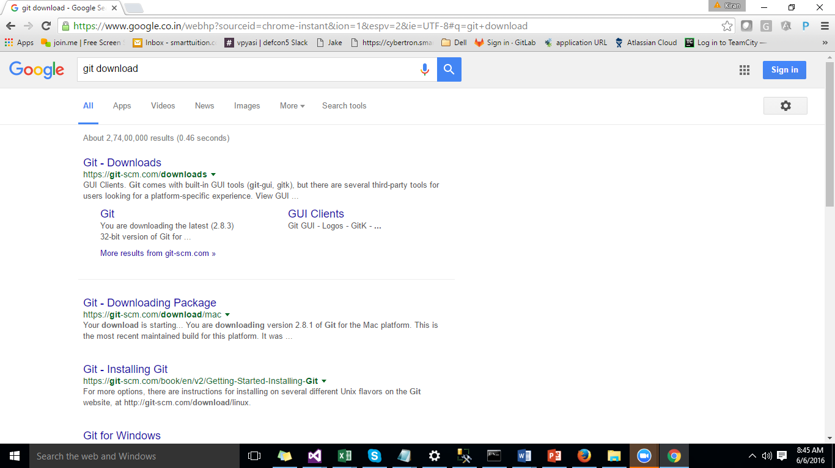

Step 2: download respective version.

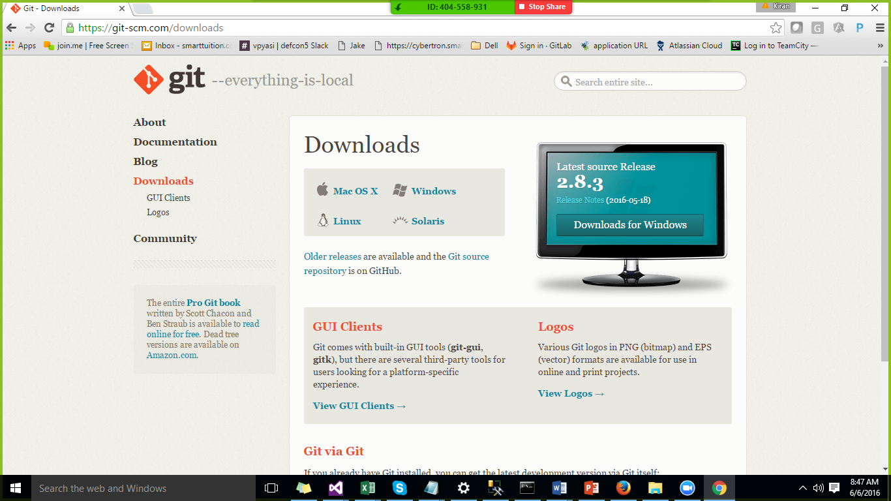

Step3. After installation you can find the following options as part of your startup.

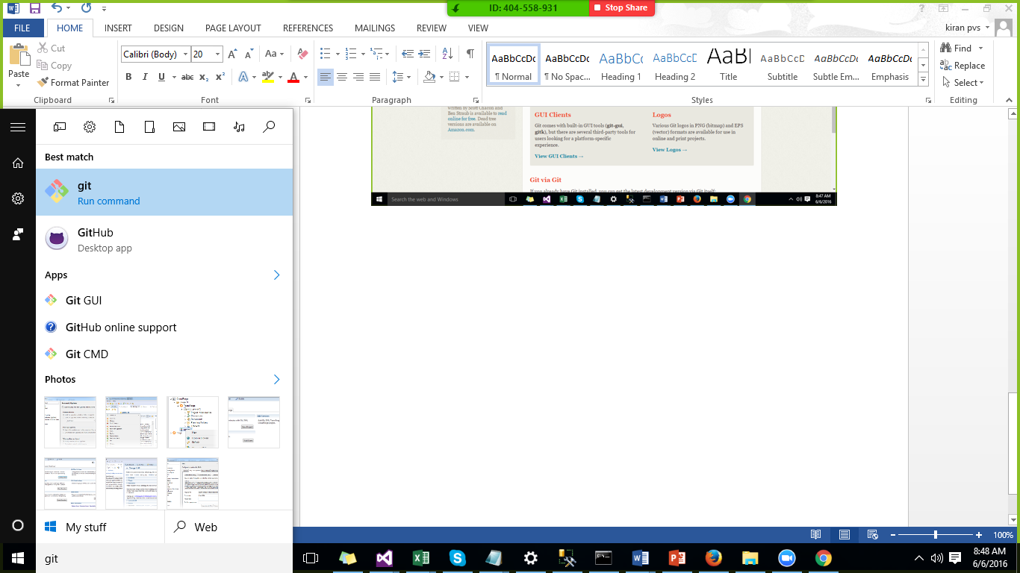

Step5: register an Account with git.

Step6. Login into the github.

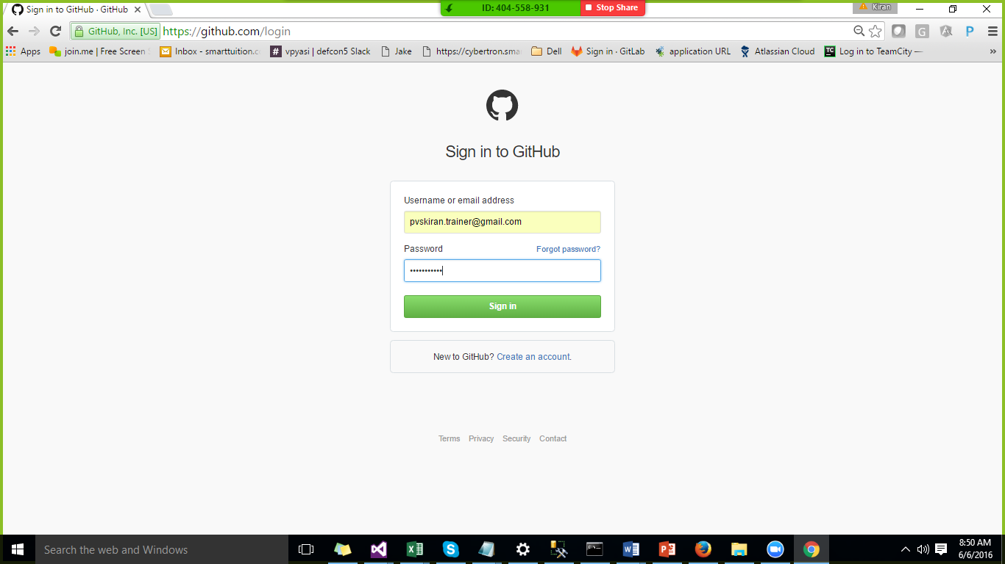

Step7. Create a new repository

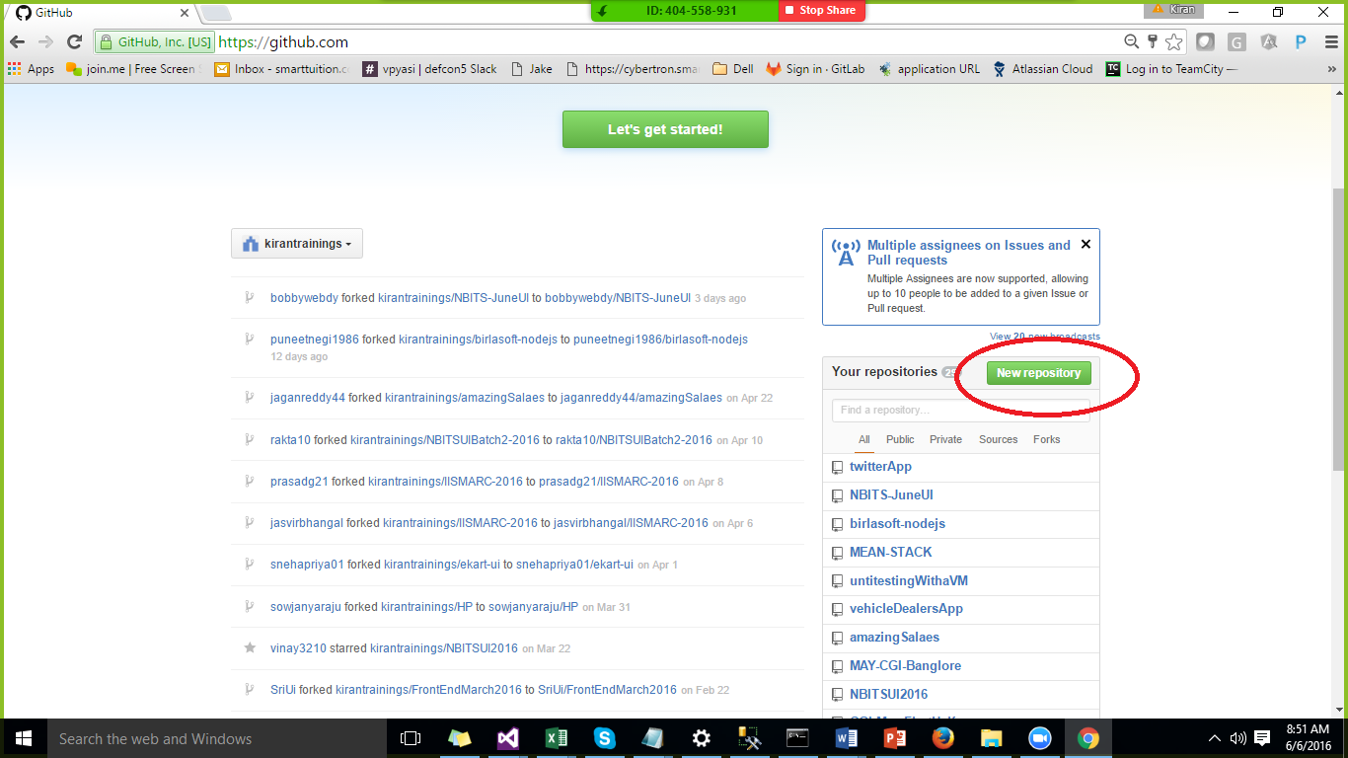

Step8.

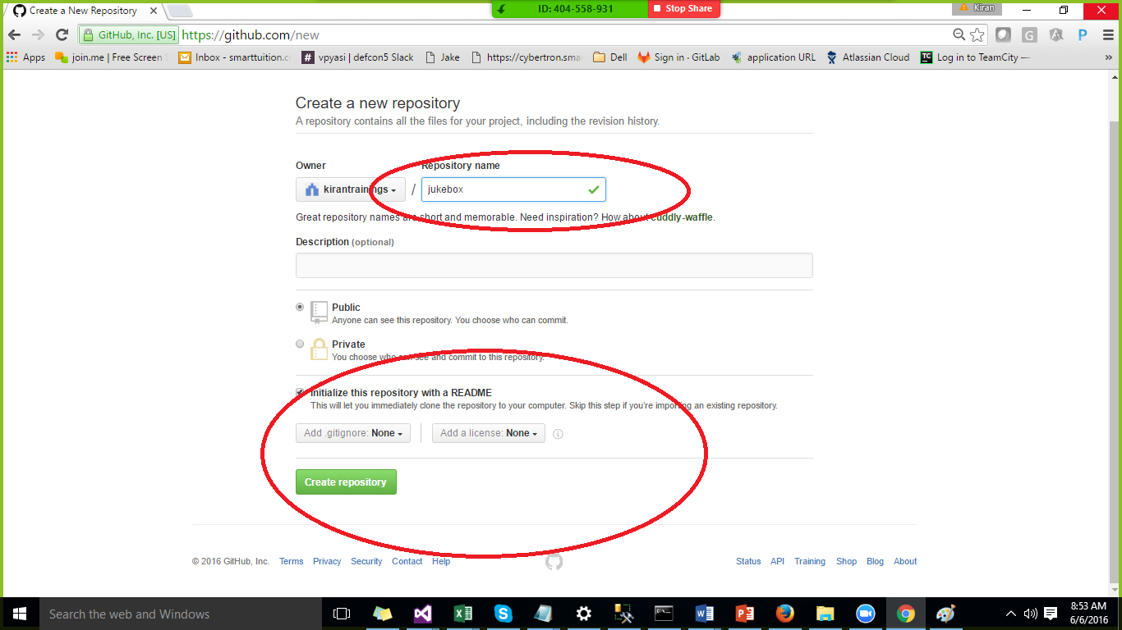

Step9. Click on create repository.

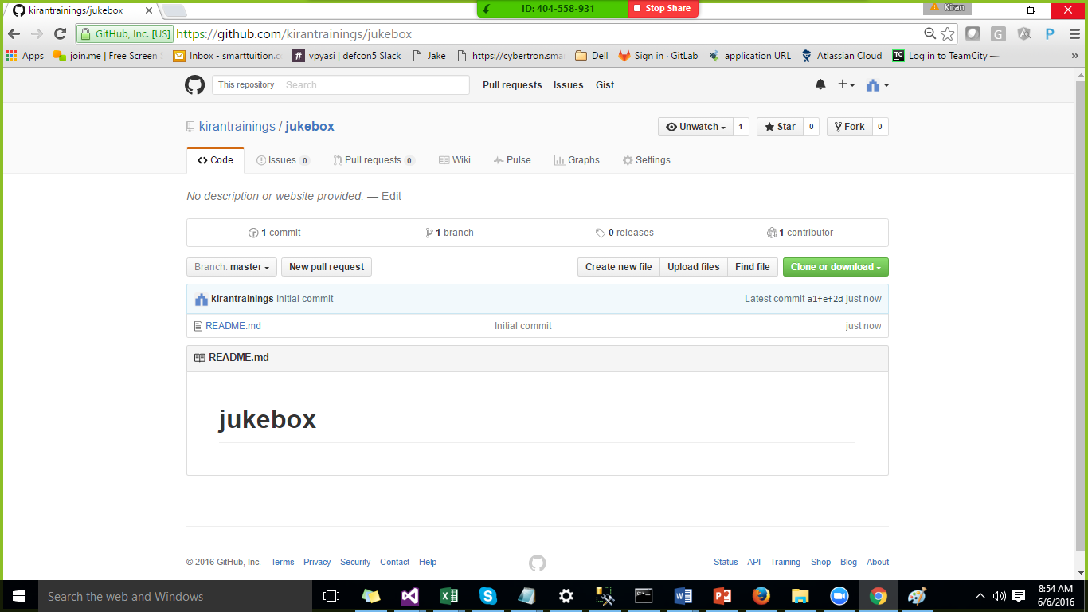

step10:

Create a folder in any drive. And right click on the folder and select gitbash

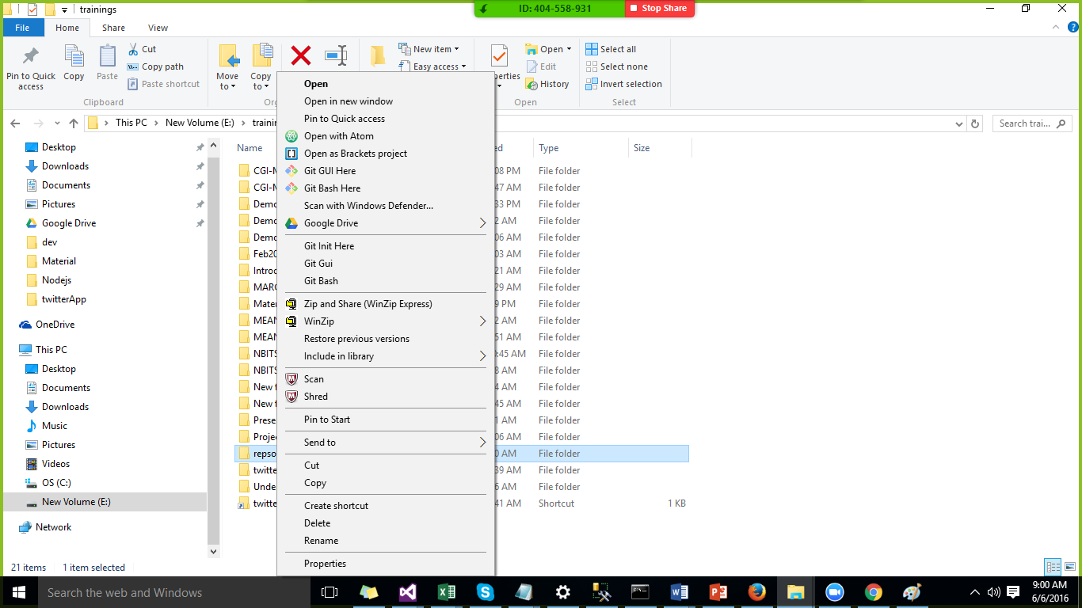

Step 11. Cloning the repository.

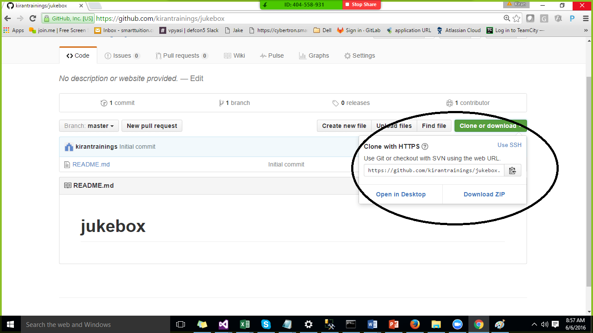

Cloning is used to get the server code into the client machine.

Command:

git clone <https://github.com/kirantrainings/jukebox.git>

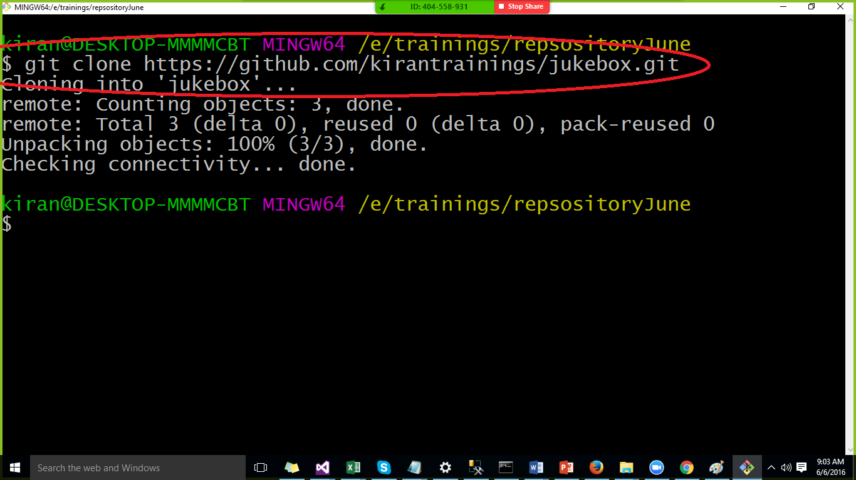

Move to the downloaded folder by using the command cd repo name.

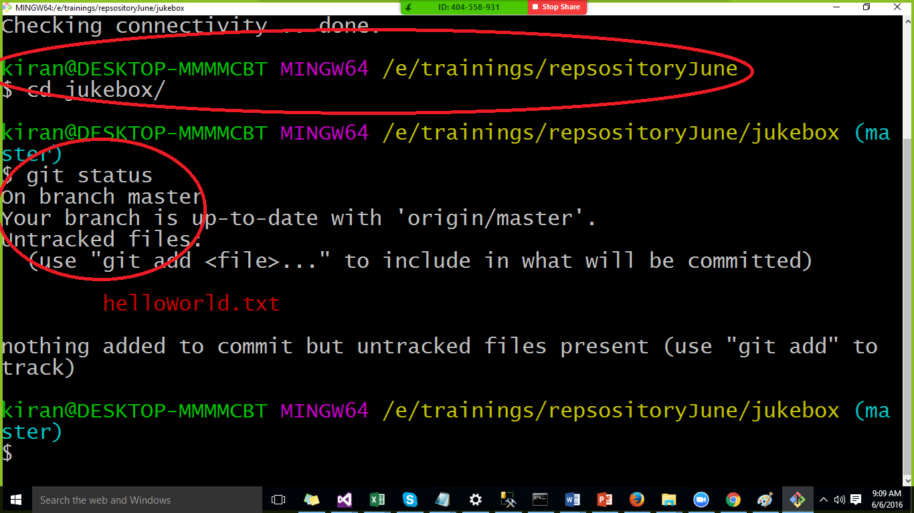

Check the newly added/modified files by using the following command.

Cmd : git status

* On which branch you are in.
* What are the modified files
* What are the newly added files.

Cmd : git add –all

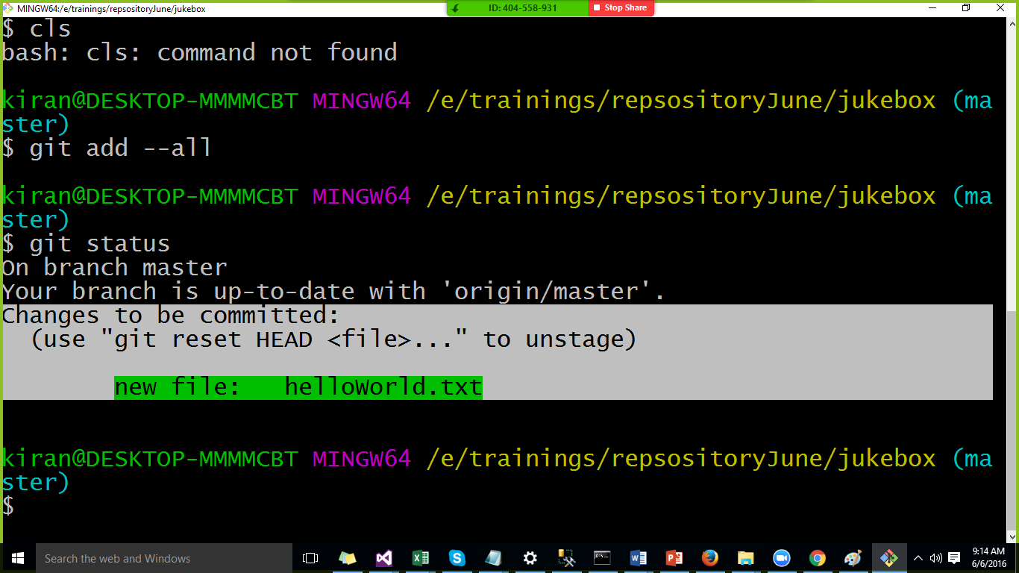

Saving the file in the local repository.

cmd: git commit –m “Added new file to the repository”.

Push the code to the server.

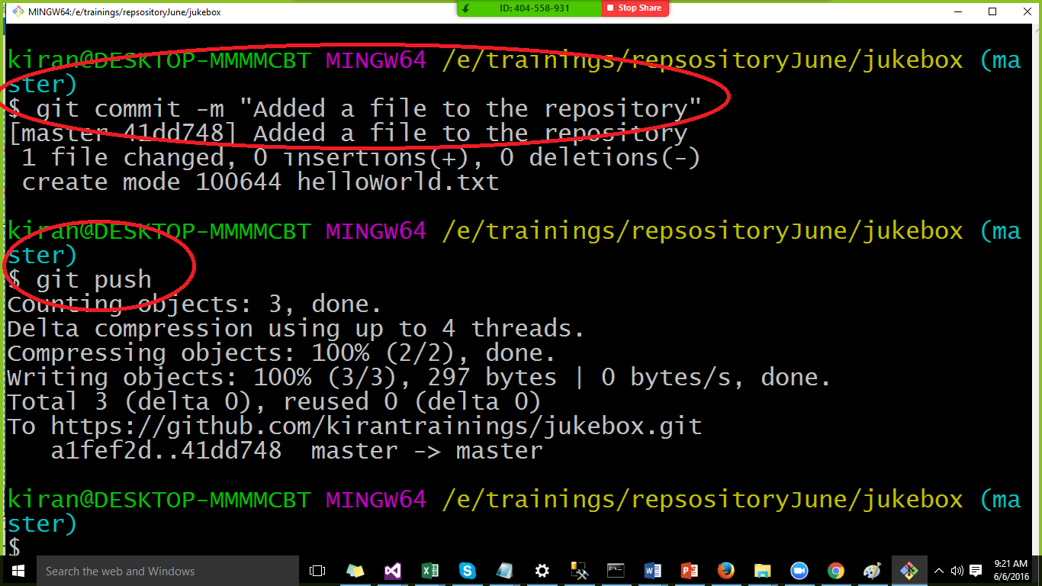

Git Branches:

